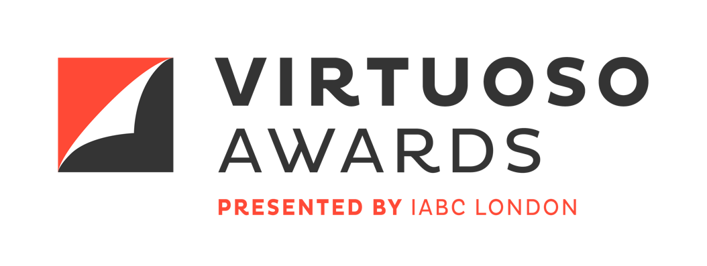

Division 4: Communication Skills – Questions in lieu of the work plan

For Division 4 entries, you will be required to answer the following questions. You will have the option of submitting these answers using text boxes on the online entry form or by uploading a PDF (cannot exceed a file size of 5 MB).

- Describe your organization. (maximum 800 characters, including spaces)
- Describe the business need that led to this project being undertaken. (maximum 1500 characters, including spaces)
- Who was(were) the audience(s) for this project? What do you know about them in relation to the communication opportunity? (maximum 1000 characters, including spaces)
- What were the measurable objectives for the project? Please provide no more than three objectives and describe how they are aligned with the business need. (maximum 1000 characters, including spaces)
- What were the key messages for the project? (max. three; 1000 characters total, including spaces)
- Describe the resources (budget, time, others) available for the project and how effectively they were managed. (maximum 1000 characters, including spaces)
- Provide a brief summary of how you used these insights (business need, audiences, objectives and key messages) to guide the development of your project. (1500 characters maximum)
- How well were the measurable objectives met? Please show the relationship between the objectives you set and the results you achieved. (maximum 1000 characters, including spaces)

